# **Tutorial: From Excel workbook to stunning report in**

# **Power BI Desktop**

**Prepare your data**

In **Navigator**, you have the option to *transform* or *load* the data. The Navigator provides a preview of your data so you can verify that you have the correct range of data. Numeric data types are italicized. If you need to make changes, transform your data before loading. To make the visualizations easier to read later, we do want to transform the data now. As you do each transformation, you see it added to the list under **Query Settings** in **Applied Steps**

1. Select the **Financials** table, and choose **Transform Data**.

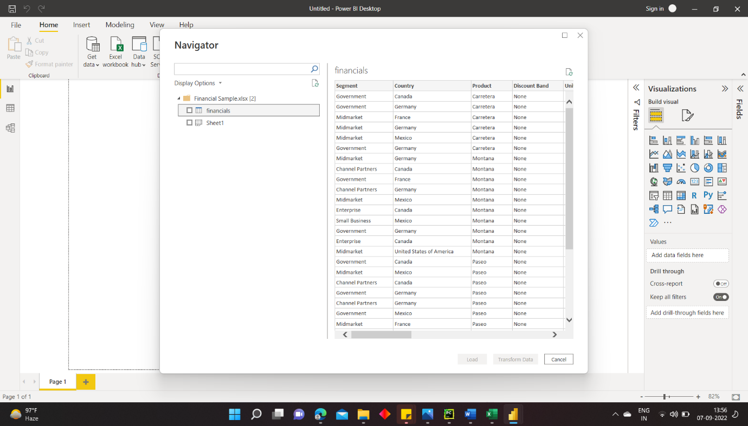

1. Select the **Units Sold** column. On the **Transform** tab, select **Data Type**, then select **Whole Number**. Choose **Replace current** to change the column type.

The top data cleaning step users do most often is changing data types. In this case, the units sold are in decimal form. It doesn’t make sense to have 0.2 or 0.5 of a unit sold, does it? So, let’s change that to whole number.

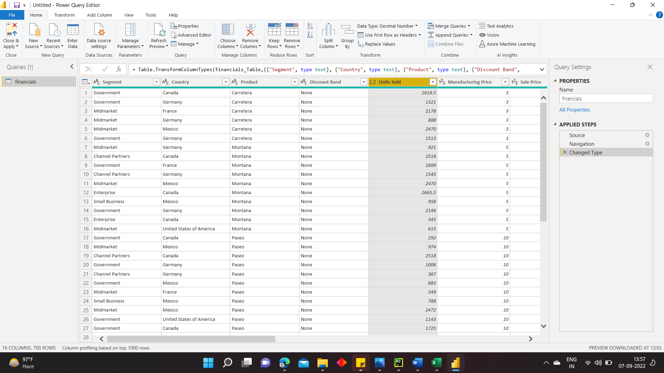

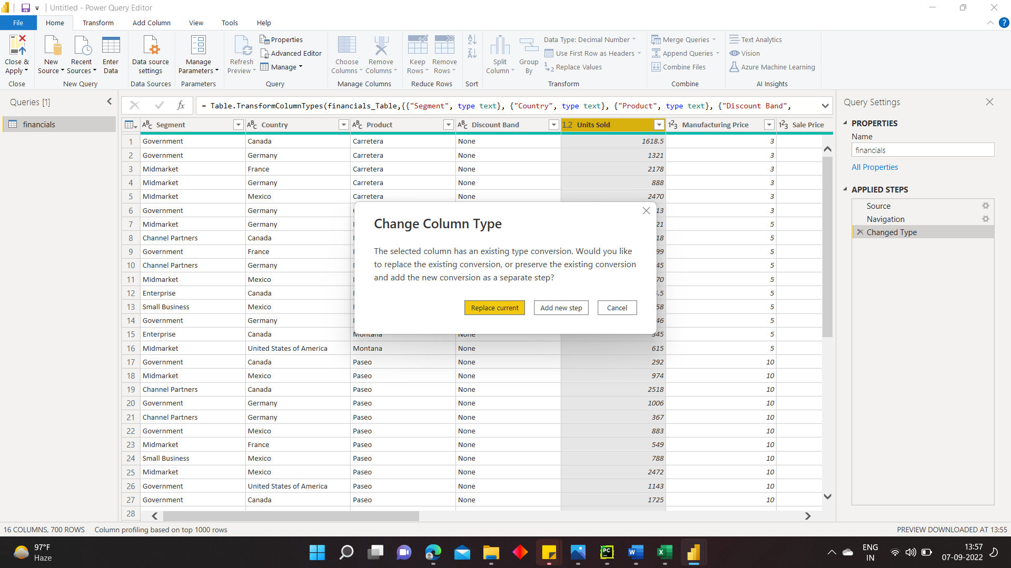

1. Select the **Segment** column. We want to make the segments easier to see in the chart later, so let’s format the Segment column. On the **Transform** tab, select **Format**, then select **UPPERCASE**.

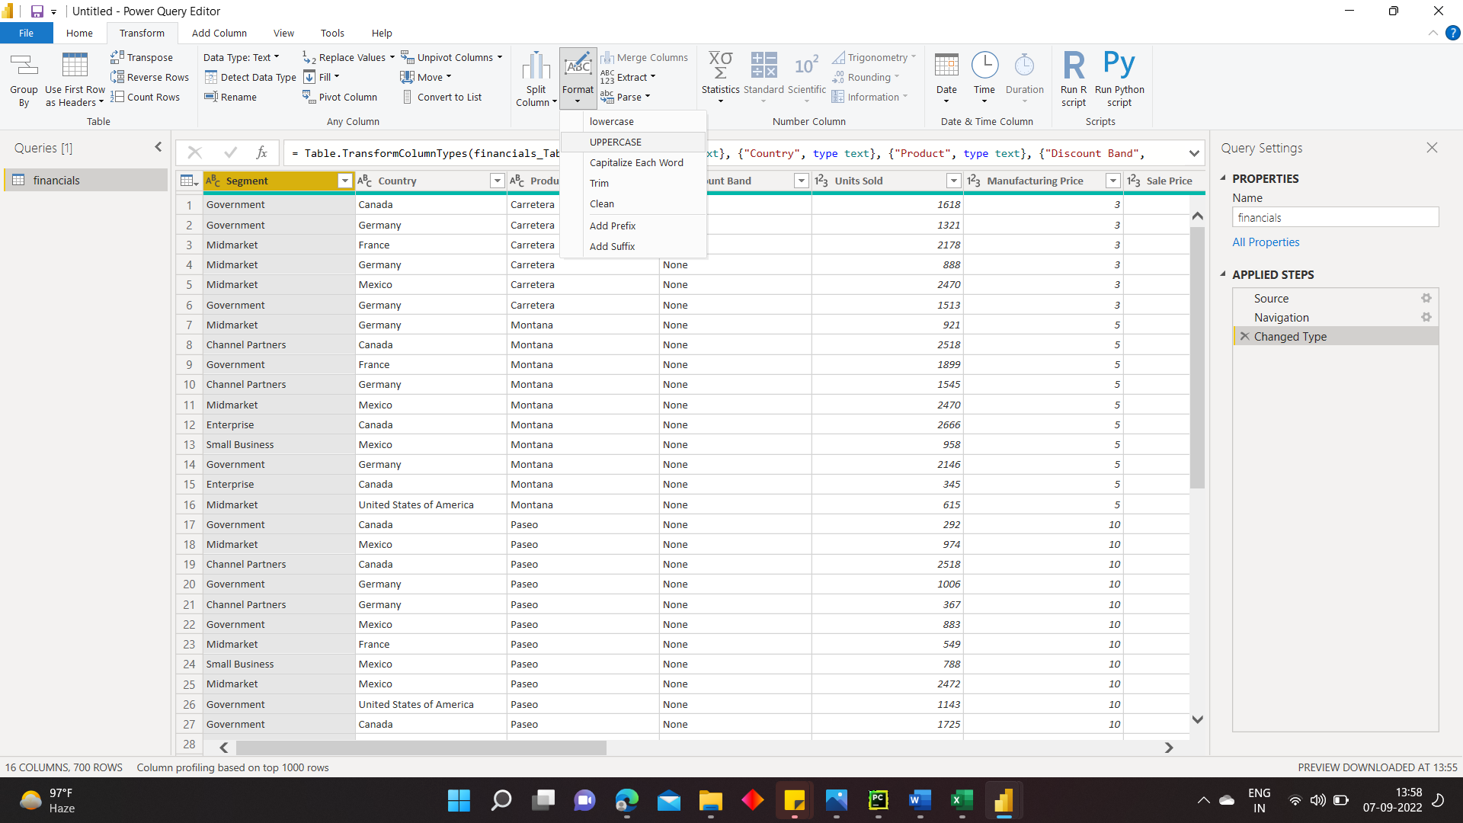

In uppercase

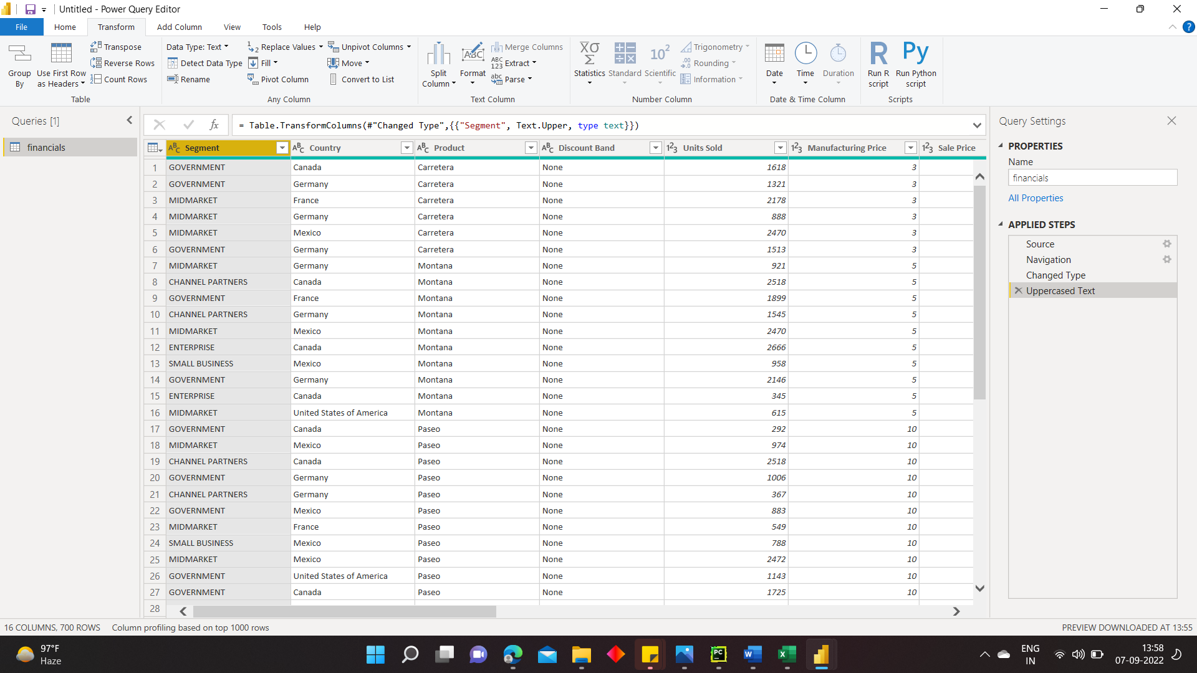

1. Let's shorten the column name from **Month Name** to just **Month**. Double-click the **Month Name** column, and rename to just **Month**.

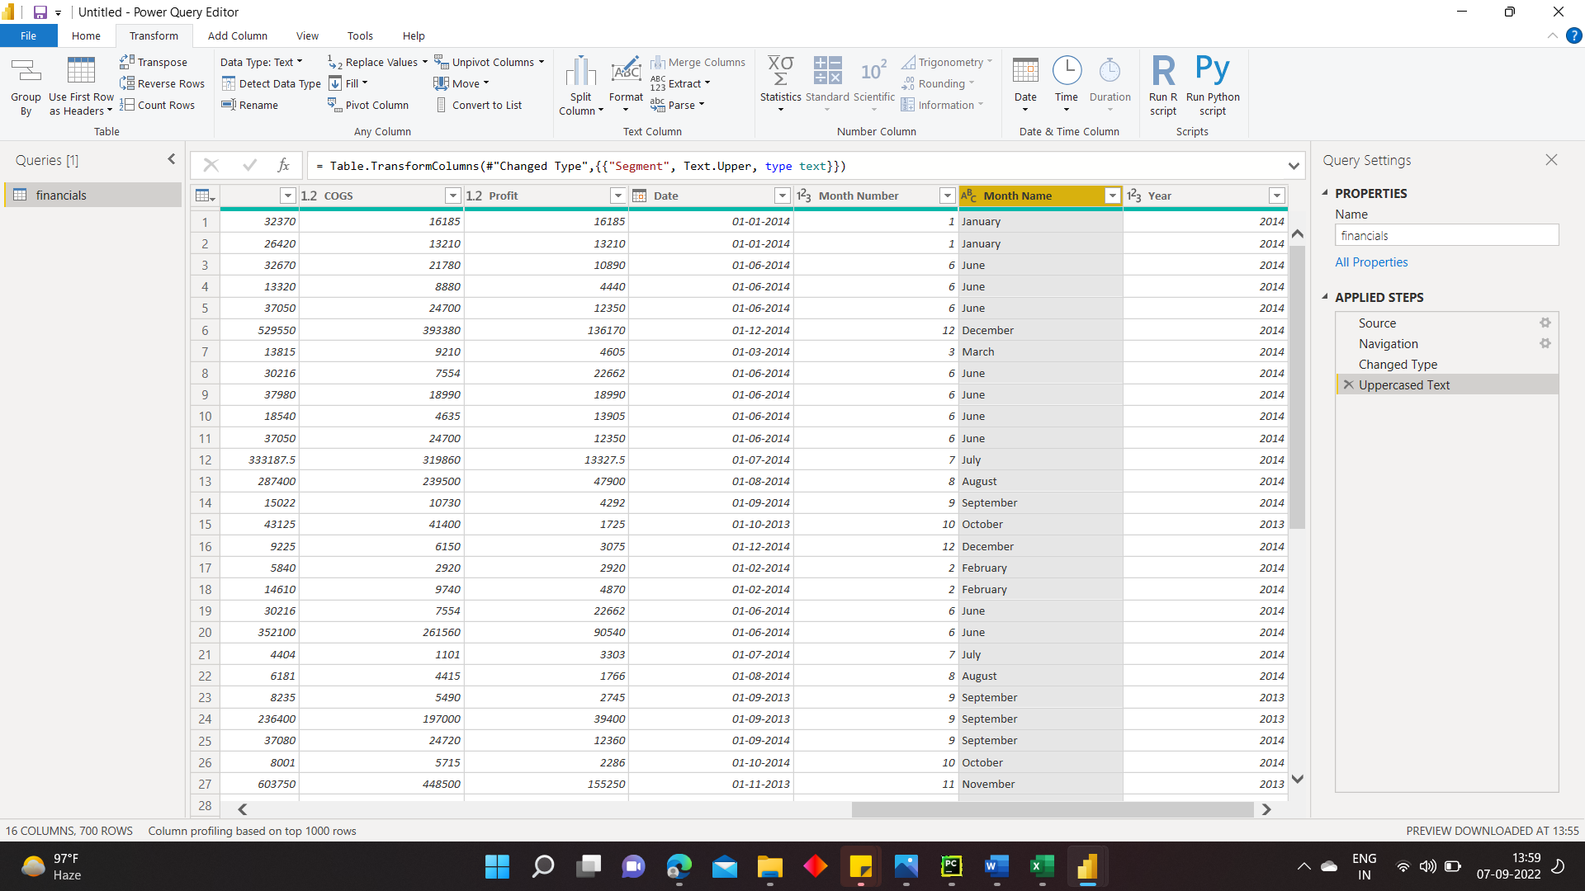

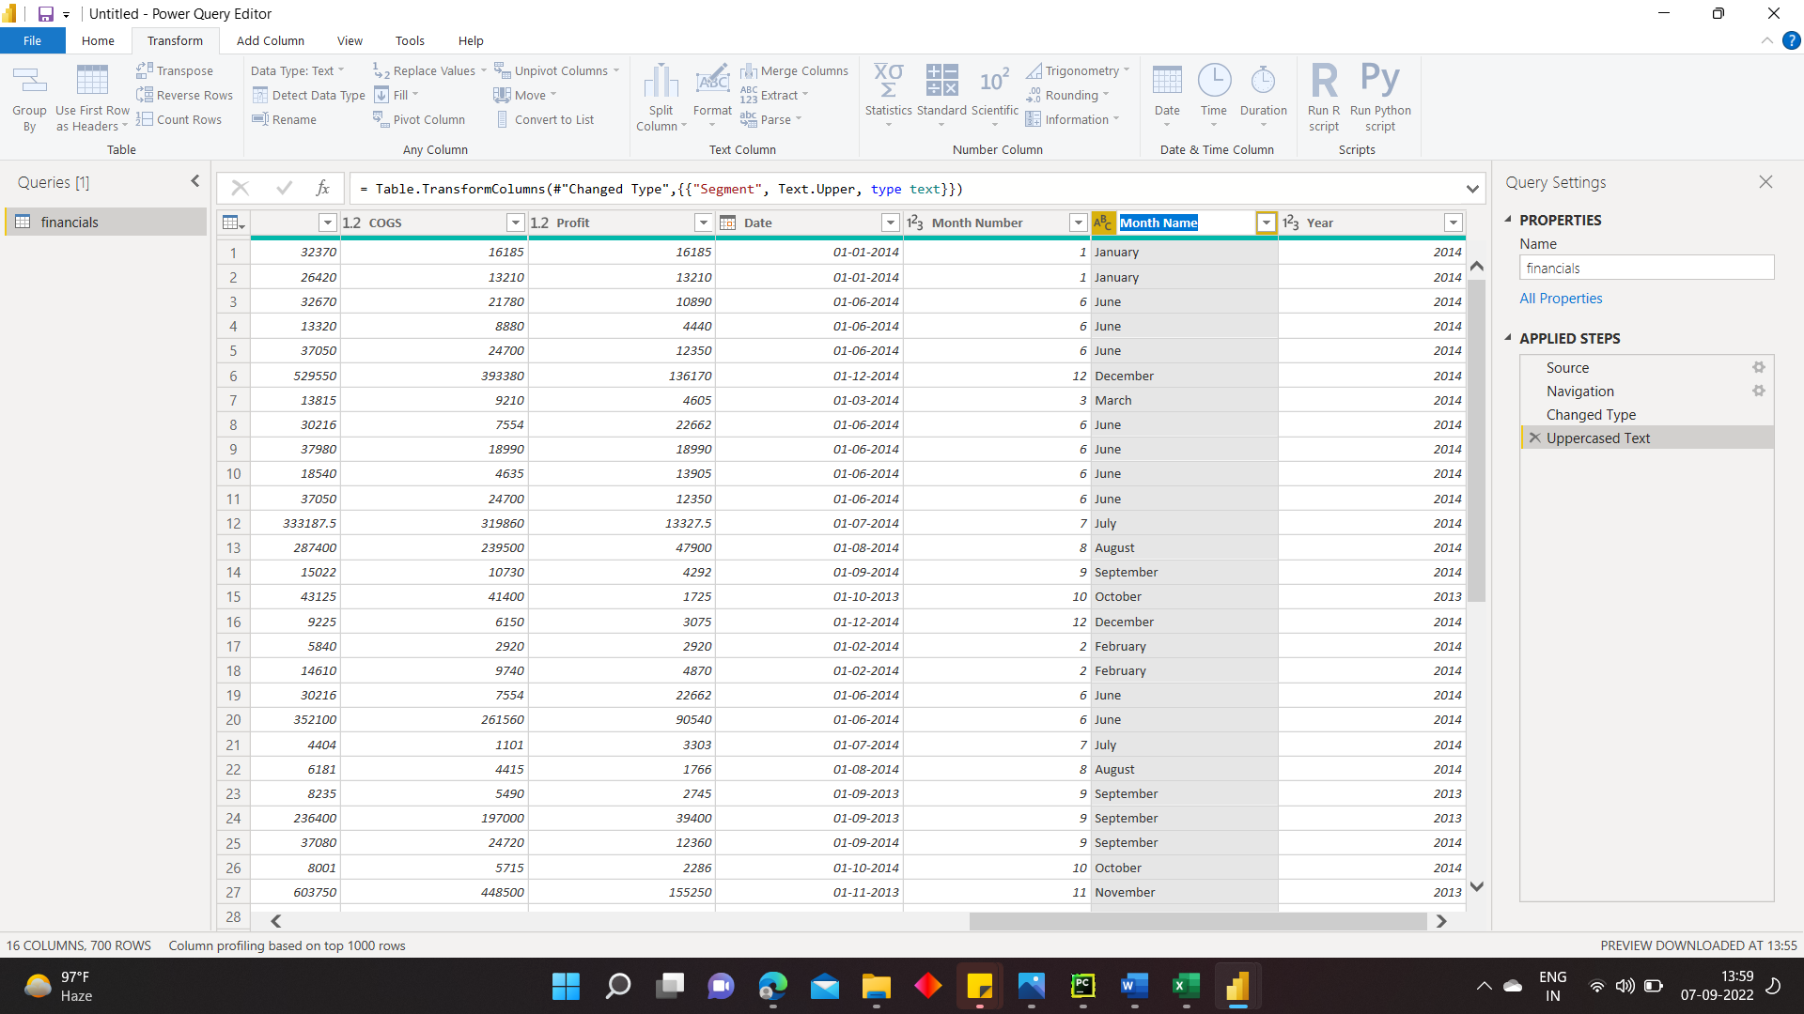

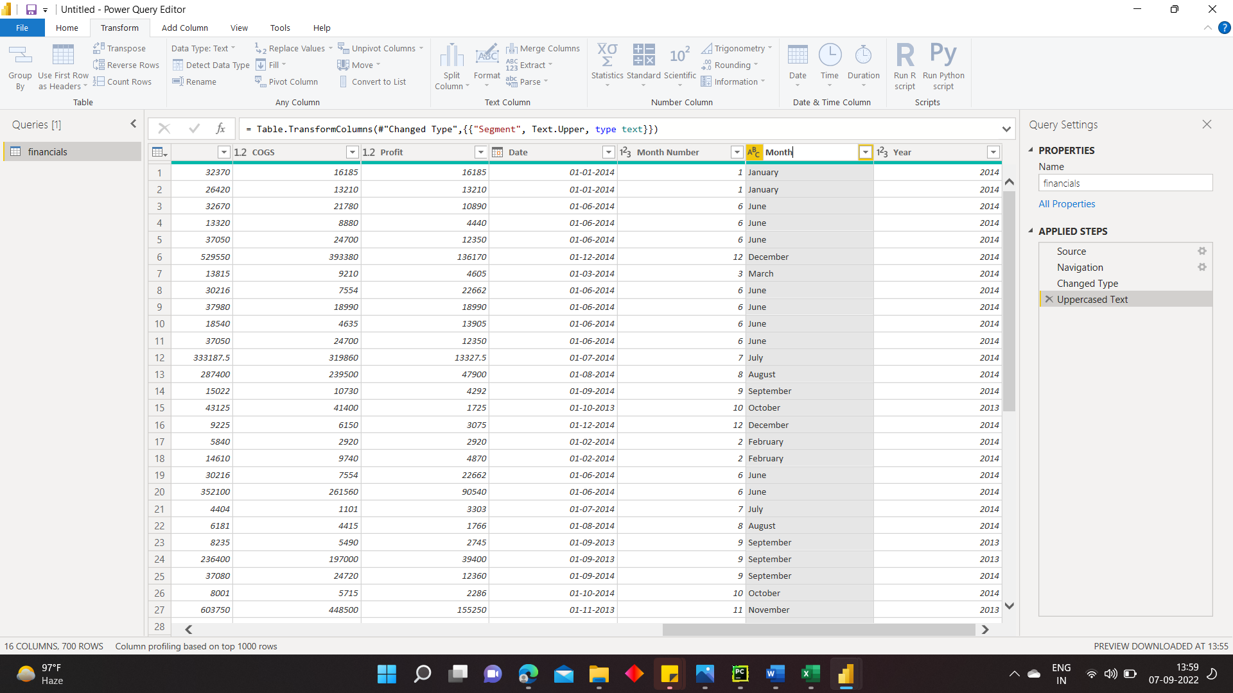

1. In the **Product** column, select the dropdown and clear the box next to **Montana**.

We know the Montana product was discontinued last month, so we want to filter this data from our report to avoid confusion.

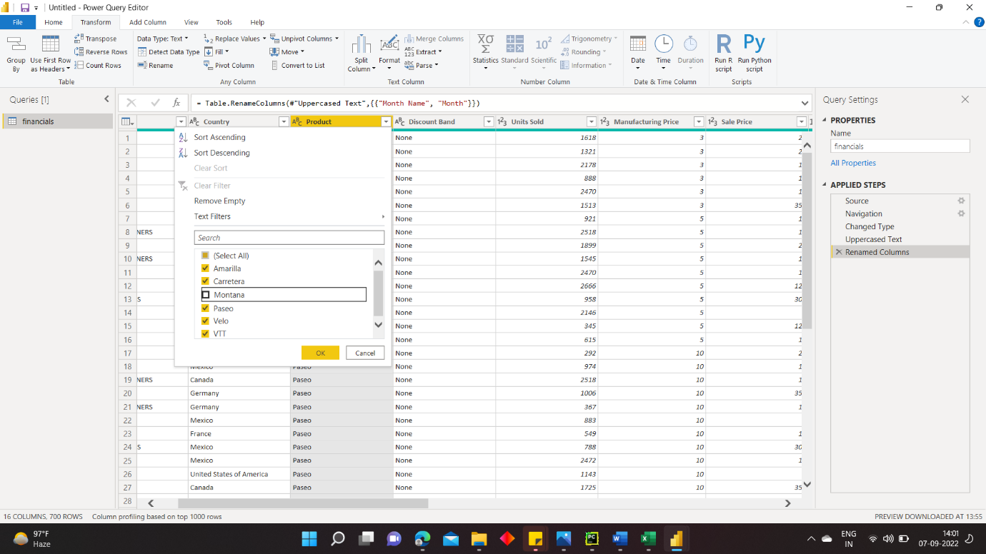

After removing the Montana product table view.

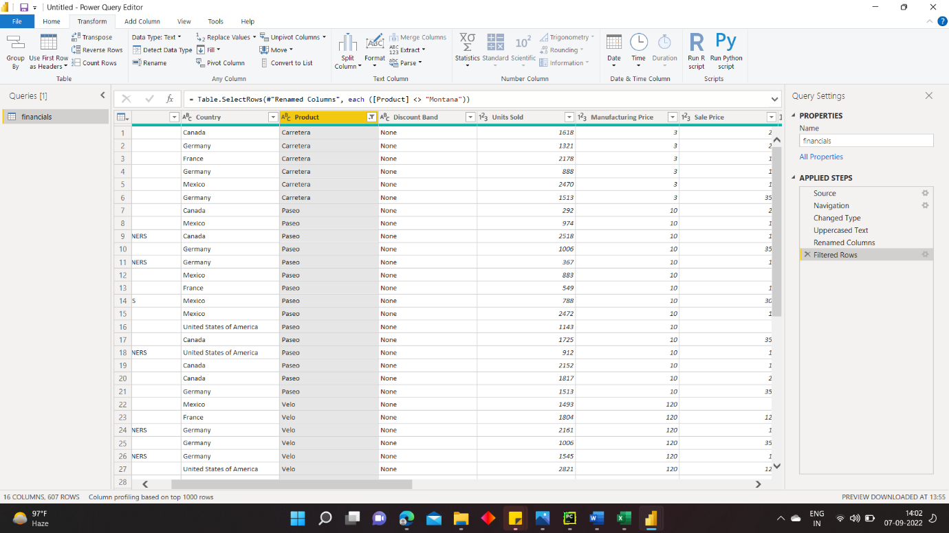



1. You see that each transformation has been added to the list under **Query Settings** in **Applied Steps**.



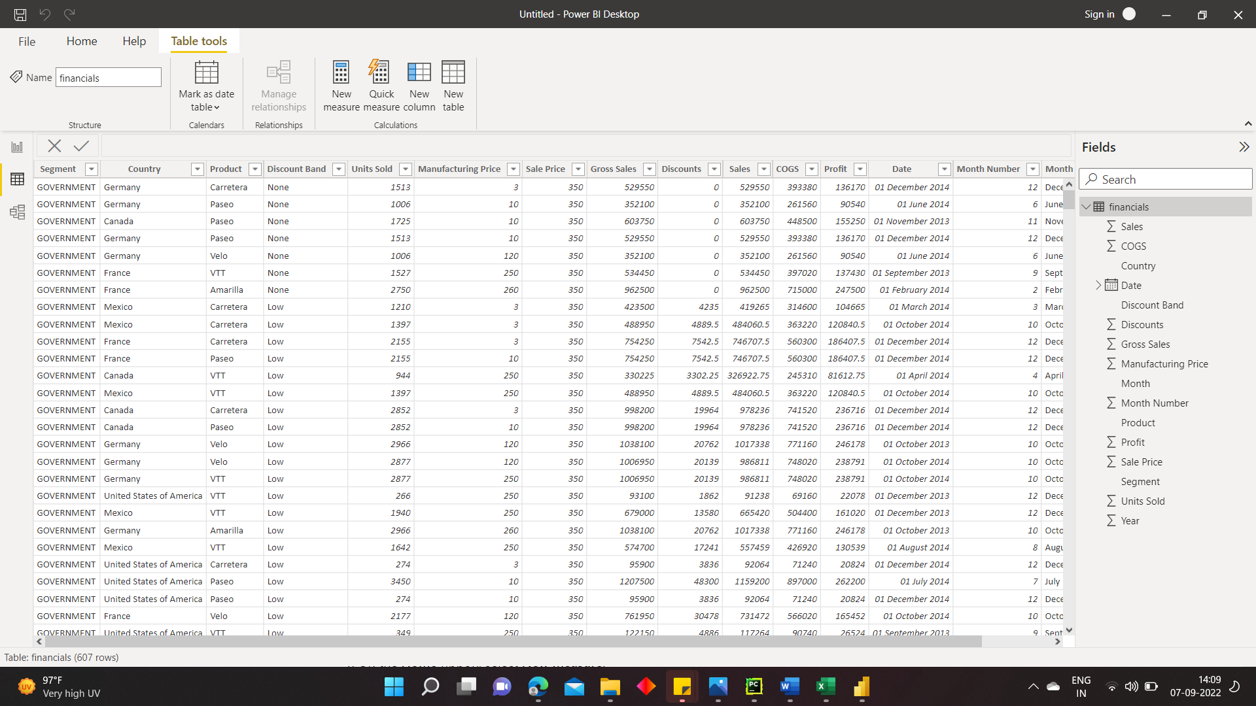

1. Back on the **Home** tab, select **Close & Apply**. Our data is almost ready for building a report.

You see the Sigma symbol in the Fields list? Power BI has detected that those fields are numeric. Power BI also indicates the date field with a calendar symbol.

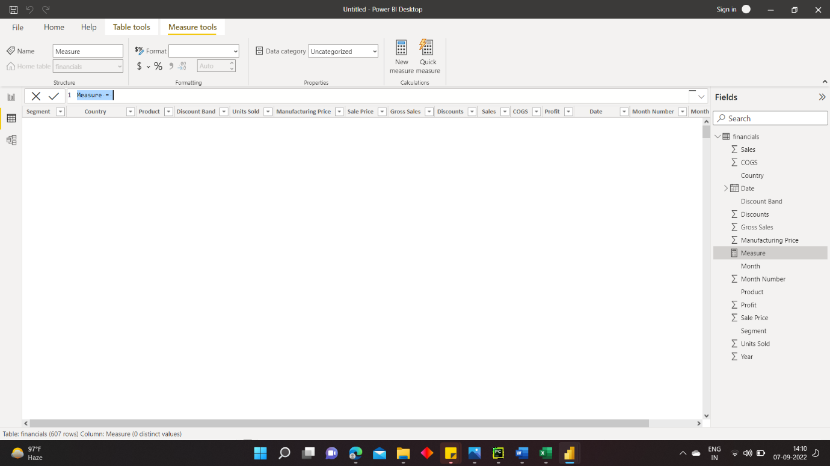

### Extra credit: Write an expression in DAX

Writing measures and creating tables in the DAX formula language is super powerful for data modeling. There's lots to learn about DAX in the Power BI documentation. For now, let's write a basic expression and join two tables.

1. On the **Home** ribbon, select **New measure**.
2. Type this expression to add all the numbers in the Units Sold column.
3. Now select the **Data** view on the left.

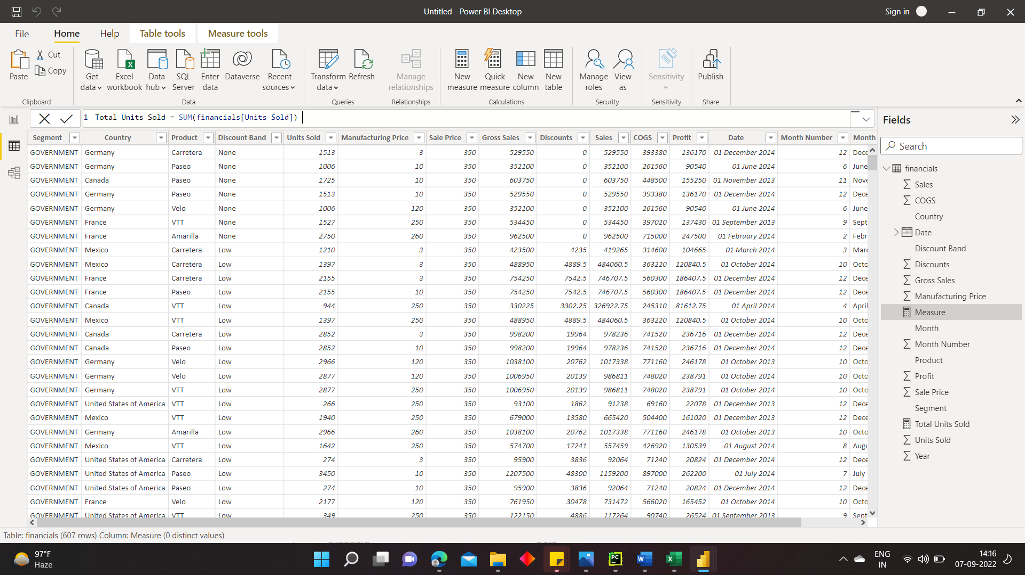

1. Type this expression to generate a Calendar table of all dates between January 1, 2013, and December 31, 2014.

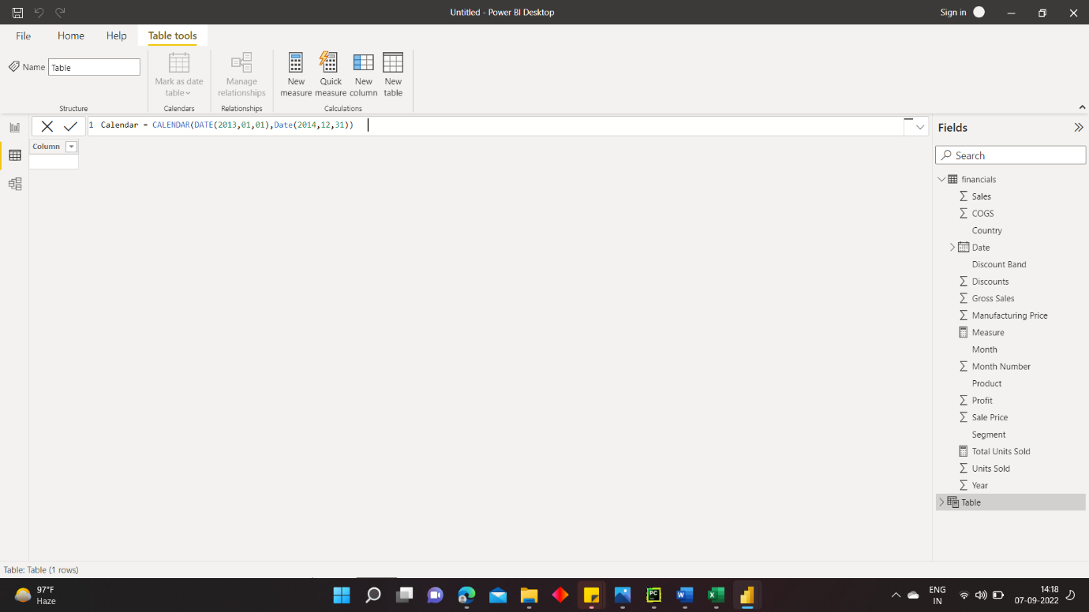

1. Drag the **Date** field from the financials table to the **Date** field in the Calendar table to join the tables, and create a relationship between them.

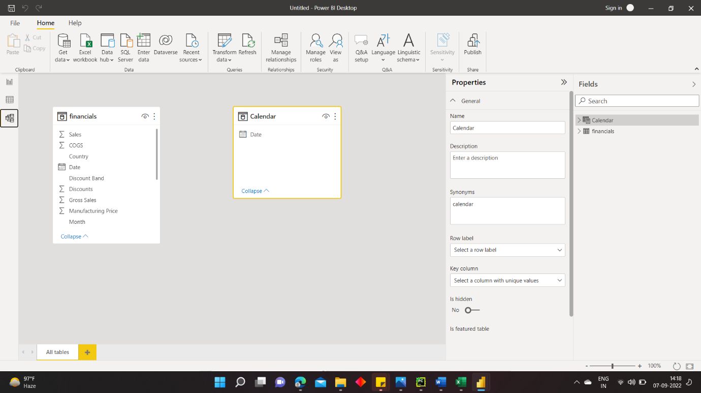

## Build your report Visual 1: Add a title

1. On the **Insert** ribbon, select **Text Box**. Type “Executive Summary – Finance Report”.
2. Select the text you typed. Set the **Font Size** to 20 and **Bold**.

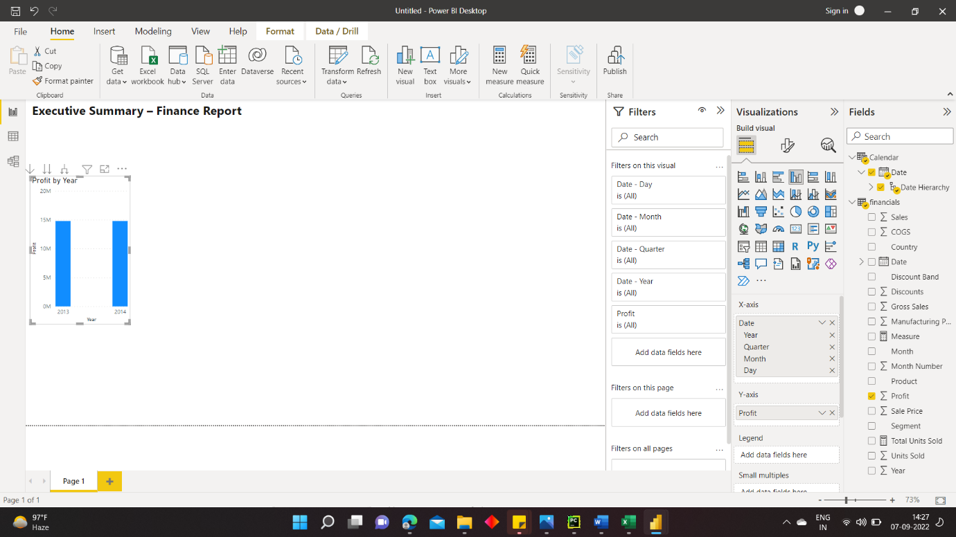

### Visual 2: Profit by Date

Now, you create a line chart to see which month and year had the highest profit.

1. From the Fields pane, drag the **Profit** field to a blank area on the report canvas. By default, Power BI displays a column chart with one column, Profit.
2. Drag the **Date** field to the same visual. If you created a Calendar table in [Extra credit: Create a table in DAX](https://docs.microsoft.com/en-us/power-bi/create-reports/desktop-excel-stunning-report#extra-credit-write-an-expression-in-dax) earlier in this article, drag the **Date** field from your Calendar table instead.
3. Power BI updates the column chart to show profit by the two years.

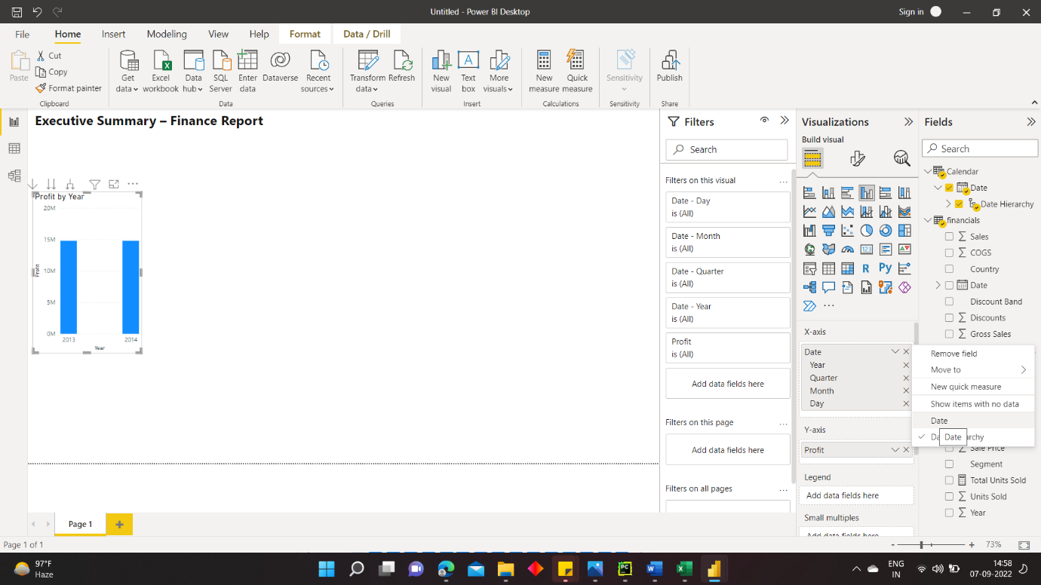

4) Power BI updates the column chart to show profit for each month.

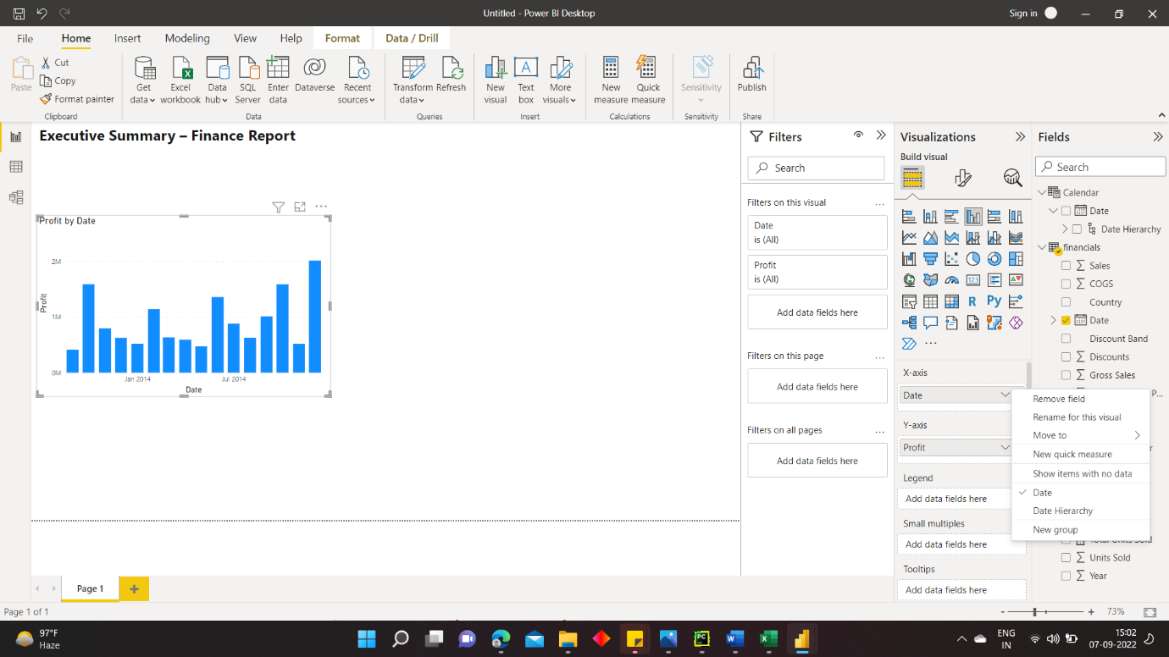

5) In the Visualizations pane, change the visualization type to **Line chart**.

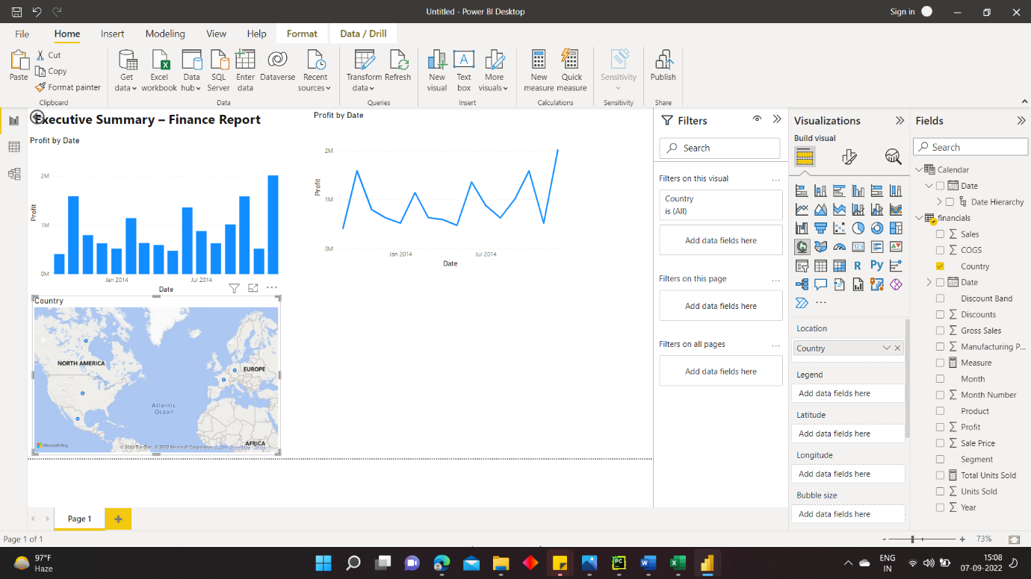

### Visual 3: Profit by Country

Create a map to see which country had the highest profits.

1. From the Fields pane, drag the **Country** field to a blank area on your report canvas to create a map.
2. Drag the **Profit** field to the map.
3. Power BI creates a map visual with bubbles representing the relative profit of each location.

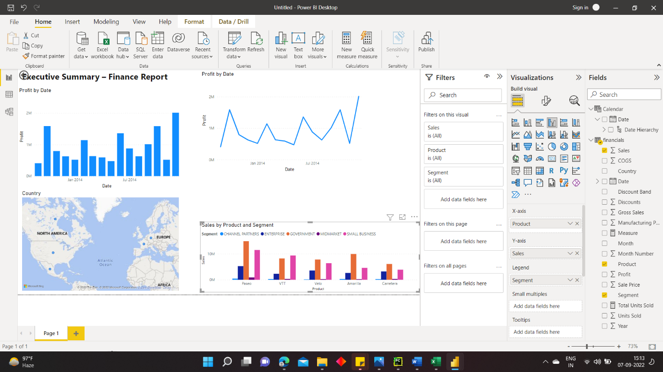

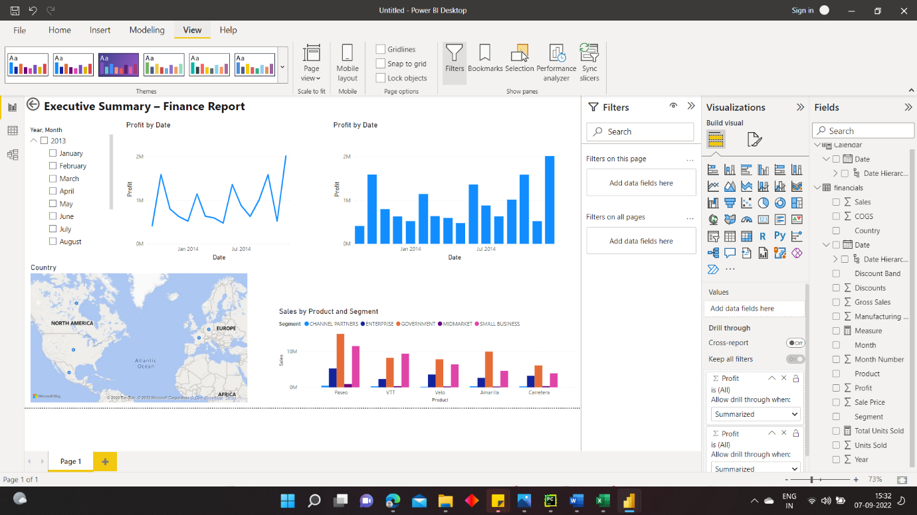

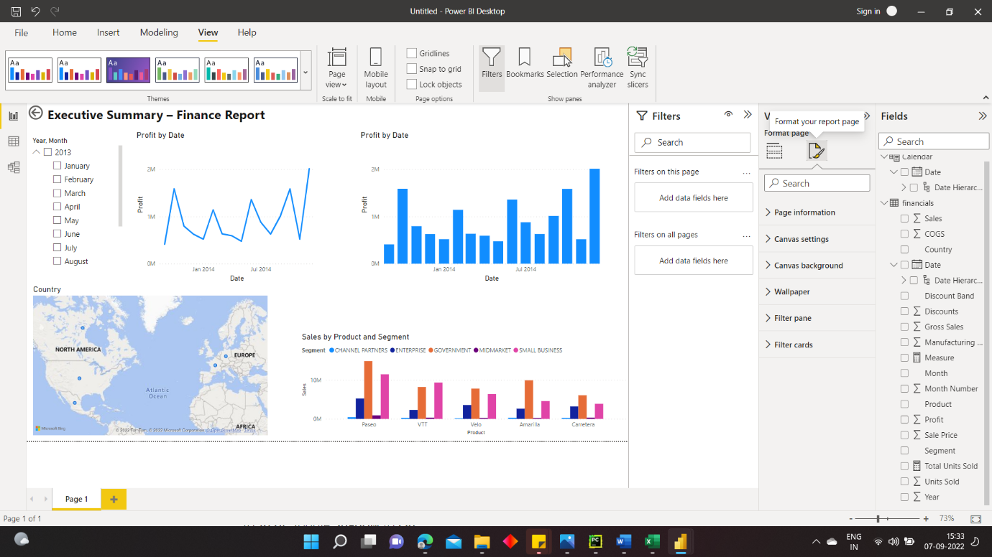

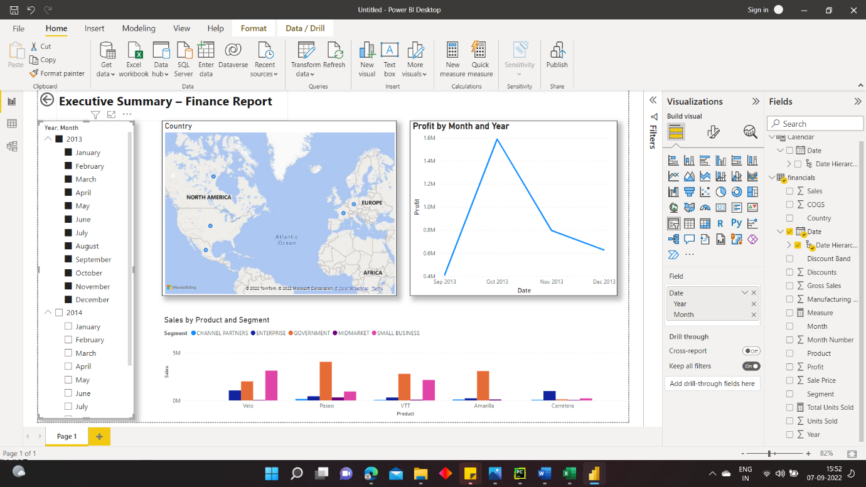

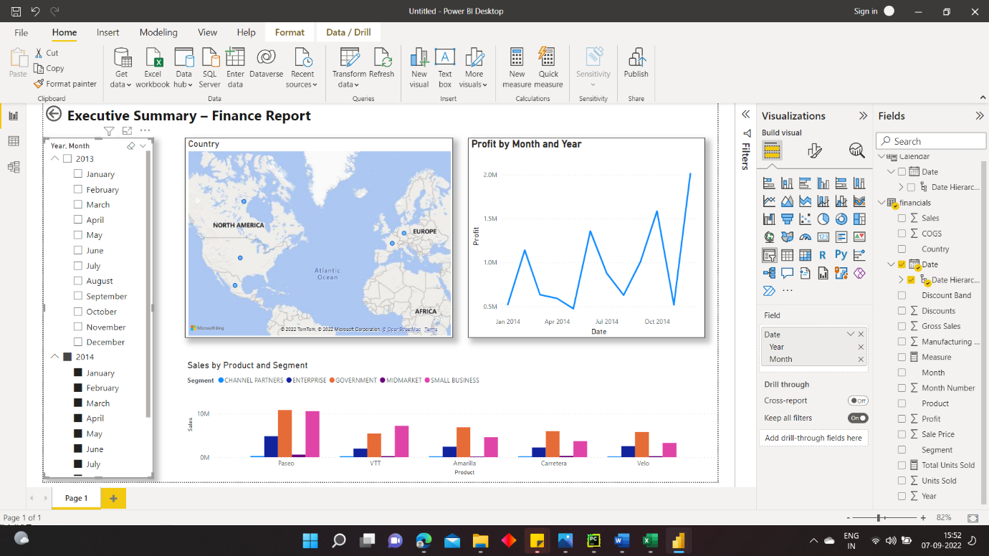

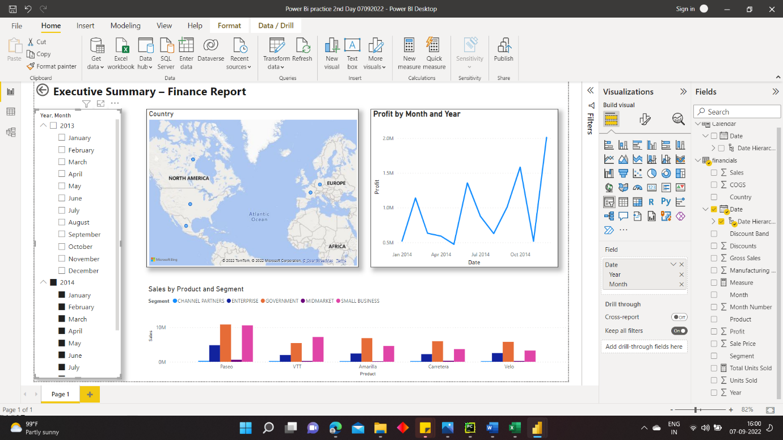

**In summary, this report answers your manager’s top questions:**

* **Which month and year had the most profit?**

**December 2014**

* **Which country is the company seeing the most success in?**

**In Europe, specifically France and Germany.**

* **Which product and segment should the company continue to invest in?**

**The company should continue to invest in the Paseo product and target the Small Business and Government segments.**

**Ankita Bharti**

**Submission Date: 08/09/2022**